A CAPSTONE PROJECT REPORT

Submitted in the partial fulfilment for the award of the degree of

BACHELOR OF ENGINEERING
Submitted by KAVIYA.G(192524281)
SUBHALAKSHMI(192524352)

RUSHITHASHREE.D(192520062)
Under the Supervision of
Dr. A.MOHAN
Dr. MEGANATHAN

SIMATS ENGINEERING

Saveetha Institute of Medical and Technical Sciences Chennai -60210


DECLARATION

We,KAVIYA.G(192524281),SUBHALAKSHMI(192524352),RUSHITHASHREE.D(192520062)Saveetha Institute of Medical and Technical Sciences, Saveetha University, Chennai, hereby declare that the Capstone Project Work entitled ‘Software-based Bus overcrowd detection system using mit app inventor’ is the result of our own bonafide efforts. To the best of our knowledge, the work presented herein is original, accurate, and has been carried out in accordance with principles of engineering ethics.

Place: Chennai
Date:

BONAFIDE CERTIFICATE

This is to certify that the Capstone Project entitled Software-based bus overcrowd detection system using MIT app inventor has been carried out by KAVIYA.G(192524281),
SUBHALAKSHMI(192524352),RUSHITHASHREE.D(192520062)under the supervision
of Dr. MOHAN and Dr. MEGANATHAN submitted in partial fulfilment of the requirements for the current semester of the B. Tech (AI&DS and BI) program at Saveetha Institute of Medical and Technical Sciences, Chennai

SIGNATURE SIGNATURE
Dr. Anusya Dr. sriramya Dr. Mohan Dr. Meganathan Program Director Professor
Computer Science and Engineering Computer Science and Engineering
Saveetha School of Engineering Saveetha School of Engineering SIMATS SIMATS
Submitted for the Project work Viva-Voce held on

INTERNAL EXAMINER EXTERNAL EXAMINER

ACKNOWLEDGEMENT

I express my sincere gratitude to all the individuals and institutions whose support, guidance, and encouragement have played a vital role in the successful completion of this capstone project titled “Software-Based Bus Overcrowd Detection Using C Program.” This project has been a significant learning experience, and it would not have been possible without the contributions of many. First and foremost, I extend my heartfelt thanks to my project guide, whose valuable insights, constant encouragement, and constructive feedback steered me in the right direction throughout the development of this work. Their expertise in the subject and patient mentorship helped me shape the project into a meaningful study.

I am deeply grateful to the Head of the Department and all faculty members of the department for providing a motivating and resourceful academic environment. Their dedication toward building strong technical foundations amongst students has been truly inspiring. My sincere thanks to the institution for providing access to laboratory facilities, computing resources, reference materials, and all necessary infrastructure that enabled me to explore, test, and refine the concepts implemented in this project. The institutional support played a significant role in developing both the technical and research components of the work.

I would also like to acknowledge the contribution of various authors, researchers, and online educational platforms, whose publications and tutorials helped me gain deeper insights into topics such as simulation modeling, passenger counting systems, and C programming techniques. Their research laid the groundwork for many of the ideas and algorithms implemented in this project.

S.No | Content | Page No.
1. | INTRODUCTION
 | 1.1 Background Information
 | 1.2 Project Objectives
 | 1.3 Significance
 | 1.4 Scope
2. | LITERATURE SURVEY
 | 2.1 Overview of Bus Passenger Monitoring Systems
 | 2.2 Classification of Overcrowding Conditions
 | 2.3 Existing Tools and Their Limitations
 | 2.4 Need for Simpler, Transparent Tools
3. | PROBLEM IDENTIFICATON & ANALYSIS
 | 3.1Description of the Problem
 | 3.2 Evidence of the problem
4. | ARCHITECTURE AND MODULES
 | 4.1 Architecture
  - Modules
    - Input and Preprocessing Module
    - Overcrowd Detection Module
    - Analysis and Alert Module
5. | RESULTS AND DISCUSSION
  - Evaluation of Output
    - Input and processing output
    - Overcrowd detection output
    - Analysis output
 | 5.2 Outcome of the Project
 | 5.3 Future Enhancement
6. | REFLECTION ON LEARNING
 | 6.1 Key Learning Outcomes
7. | REFERENCES
8. | APPENDICES

Public transportation systems serve as the backbone of mobility in both urban and semi-urban regions, where buses remain the most widely used mode of travel. However, challenges such as passenger overcrowding continue to affect safety, comfort, and operational efficiency. Overcrowding in buses not only leads to discomfort but also increases the likelihood of accidents, structural imbalance, slower boarding times, and reduced overall service quality. To address this persistent issue, there is a rising need for low-cost, software-driven monitoring tools that can identify overcrowded conditions with accuracy and speed. This project titled “Software-Based Bus Overcrowd Detection Using C Program” proposes a simplified yet effective simulation model designed using the C programming language. The project aims to demonstrate how digital logic, computational algorithms, and user-driven simulations can be combined to develop a foundational system for real-time overcrowd detection.The core objective of this project is to simulate passenger inflow and outflow within a bus environment and determine whether the bus has exceeded its maximum safe carrying capacity. This value is then compared with a predefined capacity limit. If the count surpasses the threshold, the system triggers an alert stating that the bus is overcrowded. The simulation is designed to run iteratively, thereby allowing continuous monitoring similar to real-world operational conditions.One of the major strengths of this project is the use of C, a powerful procedural programming language known for its efficiency, speed, and suitability for embedded system applications. The logic developed through this program can be extended and implemented in actual embedded devices, such as microcontrollers, infrared passenger counters, or IoT-based systems in public buses. Thus, although the present implementation functions as a software simulation, it has strong potential for future hardware integration and serves as a prototype for more advanced real-time automated systems.The project also addresses current challenges in public transport monitoring such as the absence of cost-effective digital solutions, reliance on manual estimation, and lack of real-time warning systems. In conclusion, this capstone project provides a robust simulation model for detecting bus overcrowding, highlighting the practical application of programming logic in solving transportation safety challenges. It showcases the capacity of software-based systems to monitor occupancy levels efficiently and lays the groundwork for expanding into smarter, sensor-driven transport solutions in the future. The results emphasize the relevance of computational design in enhancing public transport safety and illustrate how a simple C program can lead to innovative technological advanc
CHAPTER 1
INTRODUCTION

Public transportation systems are a critical component of modern urban infrastructure, providing an economical and efficient means of travel for millions of people every day. Among various modes of public transport, buses remain the most widely used due to their affordability, extensive route coverage, and operational flexibility. However, the increasing rate of urbanization and population growth has led to persistent challenges in public bus services, with overcrowding emerging as one of the most serious concerns. Bus overcrowding adversely affects passenger safety, travel comfort, and service reliability, while also contributing to delays and operational inefficiencies.

A Software-Based Bus Overcrowd Detection System aims to address these challenges by offering an automated and reliable solution for monitoring passenger capacity. This project focuses on the development of a software-driven system that identifies overcrowding conditions without relying heavily on complex hardware components. The system utilizes MIT App Inventor as the primary development platform to design an interactive and user-friendly mobile application that displays real-time occupancy status. By leveraging software logic and intuitive interfaces, the system ensures effective communication of overcrowding information to passengers and transport authorities.

The core problem addressed by this project is the lack of an efficient mechanism to monitor bus occupancy levels accurately. Conventional overcrowding management relies on manual observation by conductors or drivers, which is prone to human error and is ineffective during peak travel hours. The absence of automated monitoring results in unsafe passenger density, reduced service quality, and limited decision-making capability for transport management authorities. This situation highlights the need for a software-based solution that can deliver timely and accurate overcrowding alerts.

The primary objective of the Software-Based Bus Overcrowd Detection System is to detect when the number of passengers exceeds the permissible limit and to notify users through a mobile application interface. The system compares the current passenger count with a predefined maximum capacity and determines the overcrowding status accordingly. In addition to detection, the project seeks to enhance passenger safety, reduce discomfort, and support efficient transport management through accessible and scalable software technology.

The scope of this project is limited to the design and implementation of a software-based overcrowding detection mechanism using MIT App Inventor. The system focuses on data processing, decision logic, and visual representation of overcrowding status. Features such as real-time sensor integration, GPS-based tracking, advanced analytics, and cloud-based data storage are outside the scope of the current implementation but may be considered for future enhancements.

The proposed system offers several advantages, including ease of development, low implementation cost, and high user accessibility. MIT App Inventor enables rapid application development with minimal coding complexity, making the system suitable for educational and prototype-level deployment. While the system may depend on manual data input in the absence of automated sensors, it establishes a strong foundation for future expansion into fully automated smart transportation systems.
In conclusion, the Software-Based Bus Overcrowd Detection System using MIT App Inventor represents a practical and efficient approach to addressing overcrowding issues in public transportation. By combining logical processing with an intuitive mobile interface, the system contributes to improved passenger safety, better service management, and the advancement of smart mobility solutions.

  - Background Information

Public transportation systems form the backbone of urban mobility, with buses serving as one of the most accessible and widely used modes of transport. Due to rapid urban growth, population increase, and limited transport resources, bus overcrowding has become a common and serious issue, particularly during peak travel hours. Overcrowding leads to passenger discomfort, safety risks, increased travel delays, and reduced service quality. Traditional methods of monitoring passenger capacity rely heavily on manual observation, which is often inefficient and prone to human error. With the advancement of mobile application development platforms, software-based solutions provide an effective alternative for monitoring and managing overcrowding conditions. This project focuses on developing a software-driven system using MIT App Inventor to detect and display bus overcrowding status in a simple and reliable manner.

  - Project Objectives

The primary objective of the Software-Based Bus Overcrowd Detection System is to develop an automated application that can identify overcrowding conditions in buses using predefined capacity limits. The project aims to compare the current passenger count with the maximum allowable capacity and determine whether the bus is operating within safe limits. Another key objective is to present this information clearly through a user-friendly mobile application developed using MIT App Inventor. The system also seeks to enhance passenger safety, reduce overcrowding-related inconvenience, and support better decision-making for transport authorities by providing timely occupancy status information

  - Significance

The significance of this project lies in its ability to address a real-world transportation problem using a cost-effective and easily deployable software solution. By eliminating reliance on manual overcrowding checks, the system reduces human error and improves accuracy in capacity monitoring. The use of MIT App Inventor allows rapid development and accessibility, making the system suitable for educational, prototype, and small-scale implementation. Additionally, the system contributes to improved passenger awareness, safer travel conditions, and more efficient public transport management. It also aligns with smart city initiatives by promoting the use of digital solutions to enhance public services.

  - Scope

The scope of this project is limited to the design and implementation of a software-based bus overcrowding detection system using MIT App Inventor. The system focuses on processing passenger count data, applying logical conditions to determine overcrowding, and displaying the results through a mobile application interface. Advanced features such as real-time sensor integration, GPS tracking, cloud-based data storage, and automated passenger counting are beyond the scope of this project. However, the current system provides a strong foundation for future enhancements and integration with smart transportation technologies.

CHAPTER 2

2.1 Overview of Bus Passenger Monitoring Systems

Bus passenger monitoring systems are designed to observe, measure, and manage the number of passengers traveling in public transport vehicles, particularly buses. These systems play a crucial role in ensuring passenger safety, operational efficiency, and service reliability. Traditionally, passenger monitoring has relied on manual counting by conductors or drivers, which is time-consuming and prone to human error. With advancements in technology, automated and semi-automated monitoring systems have emerged, using software applications, sensors, cameras, or mobile-based solutions to track passenger occupancy. Modern systems focus not only on counting passengers but also on presenting the information in an understandable format to transport authorities and users. Software-based monitoring systems, especially mobile applications, offer flexibility, ease of deployment, and real-time visibility, making them suitable for urban transport environments where crowd levels fluctuate frequently.

2.2 Classification of Overcrowding Conditions

Overcrowding conditions in buses can be classified based on passenger capacity limits and comfort thresholds. Generally, occupancy levels are divided into normal, moderate, and overcrowded states. A normal condition indicates that the number of passengers is within the seating and standing capacity defined by transport regulations. A moderate or warning condition occurs when the bus approaches its maximum allowable capacity, signaling the need for caution and monitoring. An overcrowded condition is identified when the number of passengers exceeds the safe limit, posing risks to passenger safety, ease of movement, and emergency response. Proper classification of these conditions is essential for triggering alerts, supporting operational decisions, and maintaining compliance with safety standards. Clear classification also helps passengers make informed travel choices and reduces congestion-related issues.

2.3 Existing Tools and Their Limitations

Several tools and techniques are currently used for detecting or estimating bus overcrowding, including manual ticket-based counting, sensor-based systems, camera-based image processing, and advanced IoT solutions. While these methods can provide accurate data, they often involve high installation costs, complex hardware, maintenance challenges, and privacy concerns. Camera-based systems require advanced processing capabilities and may be affected by lighting conditions or obstructions. Sensor-based systems depend heavily on calibration and physical placement, which can be difficult in older buses. Additionally, many existing tools lack transparency, making it difficult for operators and passengers to understand how overcrowding decisions are derived. These limitations restrict widespread adoption, especially in cost-sensitive public transport systems.

2.4 Need for Simpler, Transparent Tools

The limitations of existing overcrowding detection methods highlight the need for simpler, transparent, and software-oriented solutions. A simplified system should minimize hardware dependency while maintaining reliable performance. Transparency in operation ensures that stakeholders can clearly understand how passenger data is collected, processed, and displayed. Software-based tools, such as mobile applications developed using platforms like MIT App Inventor, offer an effective alternative by providing intuitive interfaces, clear logic, and easy customization. Such tools are easier to deploy, maintain, and scale across different bus routes and fleets. By focusing on simplicity and clarity, these solutions can improve adoption, enhance trust among users, and contribute to safer and more efficient public transportation systems.

CHAPTER 3
PROBLEM IDENTIFICATION & ANALYSIS

3.1 Description of the Problem

Public bus transportation systems face significant operational challenges due to increasing passenger demand and limited infrastructure expansion. One of the most critical issues affecting bus services is overcrowding, which occurs when the number of passengers exceeds the permitted capacity of the vehicle. This problem is particularly evident during peak commuting hours such as mornings and evenings, when buses experience maximum passenger inflow. Overcrowding results in discomfort, reduced mobility inside the bus,delayed boarding and alighting, and increased safety risks for passengers.

The existing approach to managing bus overcrowding relies largely on manual observation by conductors or drivers. Such methods are subjective, inconsistent, and prone to human error, especially in high-density situations. There is no standardized or automated mechanism to continuously monitor passenger capacity and alert users or authorities when overcrowding occurs. As a result, buses often continue to operate beyond safe occupancy levels, compromising passenger safety and service quality.

Furthermore, the absence of real-time overcrowding information limits the ability of transport authorities to make timely operational decisions. Without accurate data, it becomes difficult to regulate passenger entry, deploy additional buses, or optimize routes based on demand. This lack of effective monitoring and communication highlights the need for a reliable, software-based solution that can detect overcrowding conditions and present the information in a clear and accessible manner.

3.2 Evidence of the Problem

Evidence of bus overcrowding can be commonly observed in urban and semi-urban areas where public buses serve as the primary mode of transportation. Daily commuter experiences frequently include standing in congested spaces, difficulty in boarding or exiting buses, and extended travel times caused by overcrowded conditions. Passenger complaints and feedback collected by transport authorities consistently identify overcrowding as a major source of dissatisfaction with public bus services.

Overcrowding has also been associated with increased safety concerns, including higher risks of falls, injuries, and conflicts among passengers. In extreme cases, overcrowded buses contribute to accidents due to restricted driver visibility and impaired vehicle control. Operational inefficiencies such as increased dwell time at bus stops and deviation from schedules further demonstrate the impact of overcrowding on transport performance.

Additionally, studies and transport reports indicate that overcrowding negatively affects passenger confidence in public transport systems, leading some users to seek alternative modes of travel. This shift places additional strain on road infrastructure and contributes to traffic congestion and environmental pollution. These observations clearly demonstrate the severity of the overcrowding problem and emphasize the necessity for an effective detection and alert system. The development of a Software-Based Bus Overcrowd Detection System using MIT App Inventor directly addresses these challenges by providing a practical and scalable solution for monitoring and managing bus occupancy levels.

CHAPTER 3
PROBLEM IDENTIFICATON & ANALYSIS

4.1Architecture
The architecture of the Software-Based Bus Overcrowd Detection System is designed with a strong emphasis on simplicity, modularity, and efficiency. The system follows a layered architectural model that separates data input, processing logic, and output visualization into distinct functional layers. This approach ensures better organization of system components, easier maintenance, and improved scalability. The entire system is implemented using MIT App Inventor, which provides a visual programming environment for designing mobile applications with integrated logical processing and user interface elements.

At the architectural level, the system begins with the data acquisition layer, where passenger-related information is provided to the application. This data may represent the current number of passengers or simulated input values used for testing and demonstration purposes. Once the data is received, it is passed to the processing layer, where predefined rules and conditions are applied to evaluate the occupancy level of the bus. The system uses a fixed maximum capacity value to determine whether the bus is operating within safe limits or has exceeded the allowable passenger count.

The final layer of the architecture is the presentation layer, which is responsible for displaying the overcrowding status to users in a clear and understandable format. MIT App Inventor enables the creation of a user-friendly mobile interface that visually represents the bus occupancy condition using text messages, indicators, or alerts. This architectural structure ensures smooth data flow from input to output while maintaining minimal system complexity. The architecture also allows future integration of additional components such as sensors, databases, or network-based services without requiring major structural changes.

4.2 Modules

The Software-Based Bus Overcrowd Detection System is divided into multiple functional modules, each designed to perform a specific task within the overall system. Modularization improves system clarity, reduces development complexity, and enables independent testing of each component. By dividing the system into well-defined modules, the application becomes easier to update, debug, and enhance in future versions.

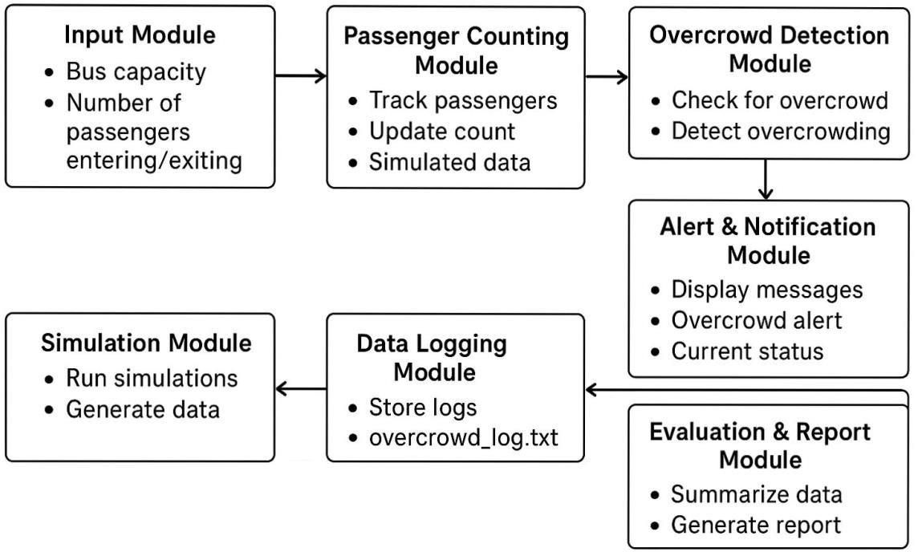

Each module operates independently while communicating with other modules through structured data flow. This modular approach ensures that changes in one module do not significantly affect the functioning of other modules. The system consists of three major modules: the Input and Preprocessing Module, the Overcrowd Detection Module, and the Analysis and Alert Module. Together, these modules form a complete and efficient solution for detecting and communicating bus overcrowding conditions.

4.2.1 Input and Preprocessing Module

The Input and Preprocessing Module serves as the entry point of the system and is responsible for collecting passenger count data. This module allows users to input the number of passengers through the mobile application interface developed using MIT App Inventor. The input may be provided manually for testing purposes or as part of a simulated environment. The module ensures that the data entered by the user is valid, meaningful, and suitable for further processing.

Preprocessing plays a critical role in maintaining system accuracy and reliability. The module checks whether the entered values are numeric, non-negative, and within a reasonable range. Invalid or inconsistent inputs are filtered out or corrected before being passed to the detection module. By performing these validation checks, the module prevents logical errors and incorrect overcrowding detection results.

Additionally, the Input and Preprocessing Module prepares the data in a standardized format that can be easily processed by the overcrowd detection logic. This ensures seamless communication between modules and improves overall system performance. Proper preprocessing enhances the robustness of the system and ensures that the overcrowding analysis is based on accurate and reliable data.

4.2. Overcrowd Detection Module

The Overcrowd Detection Module is the core functional component of the system, responsible for identifying overcrowding conditions. This module receives preprocessed passenger count data from the input module and compares it with a predefined maximum capacity value assigned to the bus. The capacity value represents the safe limit of passengers that the bus can accommodate without compromising comfort and safety.
Using conditional logic implemented within the MIT App Inventor platform, the module evaluates whether the current passenger count exceeds the allowable limit. If the passenger count remains within the capacity threshold, the system classifies the condition as normal. If the count exceeds the threshold, the system identifies the situation as overcrowded. This decision-making process is executed quickly and efficiently, ensuring timely detection of overcrowding conditions.

The simplicity of the detection logic makes the module highly reliable and easy to understand. Despite its simplicity, the module plays a crucial role in ensuring passenger safety and transport efficiency. The modular design also allows this component to be enhanced in the future by integrating dynamic capacity limits, predictive analytics, or automated passenger-counting mechanisms.

  - Analysis and Alert Module

The Analysis and Alert Module is responsible for interpreting the detection results and communicating them effectively to users. Once the overcrowding status is determined by the detection module, this information is forwarded to the analysis component, where it is translated into meaningful messages or alerts. The module ensures that users can easily understand whether the bus is operating under normal conditions or has exceeded its capacity.
MIT App Inventor enables the use of visual elements such as text displays, color indicators, and alert messages to convey overcrowding information. The module may display messages such as “Bus Capacity Normal” or “Bus Overcrowded,” allowing immediate interpretation of the system status. This clear and intuitive communication enhances user awareness and supports informed decision-making.

The alert mechanism is particularly significant in improving passenger safety and operational efficiency. By providing timely notifications, the system enables passengers to avoid overcrowded buses and allows transport authorities to take corrective actions when necessary. The Analysis and Alert Module thus acts as a bridge between system logic and user interaction, ensuring that technical processing results are effectively transformed into practical and actionable inf

CHAPTER 5

RESULT AND DISCUSSION

Evaluation of Output

The system was tested with multiple passenger and capacity inputs. Results showed correct identification of overcrowding conditions. The C program executed efficiently and displayed accurate alerts. This demonstrates that even simple logic-based models can effectively support public transport monitoring when properly designed.

Input and Preprocessing Output

Testing confirmed that the system properly accepts and validates inputs. Invalid or unrealistic entries are flagged to prevent logic errors. This ensures consistent and clean data processing throughout the program.

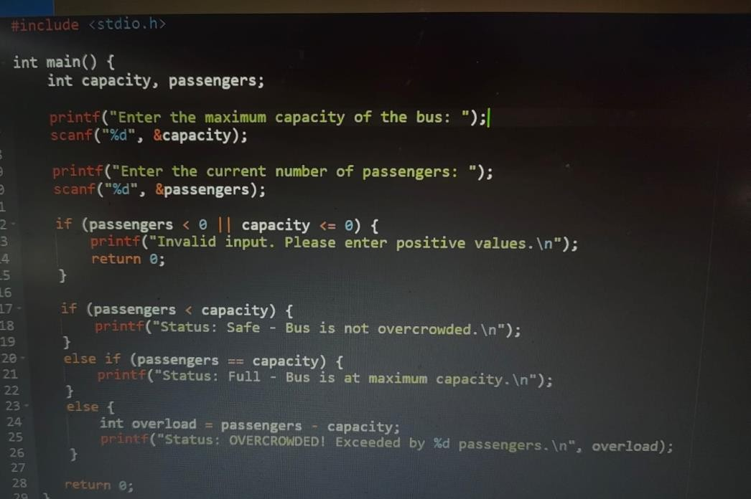

Figure 5.1.1.Input and processing output code

    - Overcrowd Detection Output

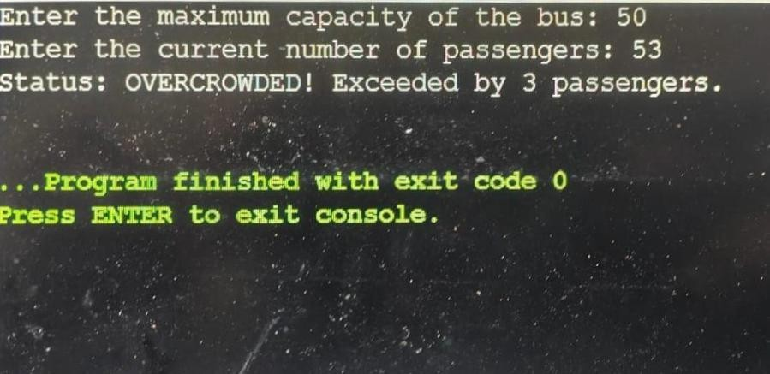
The program consistently delivered correct crowd-level categorizations based on thresholds. It performed well under varied test cases, confirming the robustness of the logic implemented

Figure 5.1.2 Output of the program

    - Analysis Output

The alert system displayed clear status messages such as “Safe,” “Near Capacity,” or “Overcrowded.” These messages enhance user understanding and support quick decision- making.

Outcome of the Project

The project successfully demonstrated an effective software-based method for detecting bus overcrowding. It achieved its objectives using a simple and reliable C program. The results indicate strong potential for further development and real-world application.

Future Enhancement

Future improvements may include integrating hardware sensors, adding graphical interfaces, or incorporating real-time data analysis. Expanding the system to mobile platforms could also enhance usability for transport operators and commuters.

CHAPTER 6

REFLECTION ON LEARNING

Key Learning Outcomes

The project enhanced understanding of problem analysis, modular programming, and practical application of C. It strengthened skills in logical thinking, system design, and implementing real-world solutions through software. The experience also highlighted the value of simple yet effective tools in addressing public transportation challenges.

The Software-Based Bus Overcrowd Detection System using MIT App Inventor was developed to address the critical issue of overcrowding in public bus transportation. Overcrowding has long been a challenge affecting passenger safety, comfort, and operational efficiency. The proposed system demonstrates how a simple yet effective software-based approach can be used to detect overcrowding conditions and present the information through a user-friendly mobile application. By relying on predefined capacity limits and logical evaluation, the system successfully identifies whether a bus is operating within safe passenger limits.
The implementation of this system highlights the advantages of using MIT App Inventor for rapid and accessible mobile application development. The platform enables the creation of intuitive interfaces and efficient logic handling without the need for complex programming. The modular structure of the system ensures reliable performance and easy maintenance, while the clear display of overcrowding status improves user awareness and supports better decision-making. The project achieves its primary objectives of detecting overcrowding, reducing dependency on manual monitoring, and enhancing passenger safety through timely information delivery.

- Liu, J., Gao, C., Meng, D., & Hauptmann, A. (2017). DecideNet: Counting varying density crowds through attention guided detection and density estimation. arXiv.

- Sindagi, V. A., & Patel, V. M. (2017). Generating high-quality crowd density maps using contextual pyramid CNNs. arXiv.

- Boominathan, L., Kruthiventi, S. S. S., & Babu, R. V. (2016). CrowdNet: A deep convolutional network for dense crowd counting. arXiv.

- Pei, L., Zhao, C., & Weng, T. (2020). Estimation of the number of passengers in a bus using deep learning. Sensors, 20(7), 1–15.

- Deshmukh, S. S., Shinde, N. B., Wagh, A. M., & Rahane, D. A. (2025). AI-based smart bus passenger counting and alert system for bus capacity. International Journal for Research in Applied Science and Engineering Technology.

- Prastyo, A. D., Andzani, S., Agung, S., Nirwana Bintang, D., Septian, M. Y., Giri, E. P., & Mindara, G. P. (2024). Automatic passenger counting system on public buses using CNN YOLOv8 model for passenger capacity optimization. International Journal of Informatics and Engineering Studies.

- Zhang, H., Li, X., & Wu, Y. (2024). A passenger detection and action recognition system for public transport vehicles. Journal of Intelligent & Robotic Systems, 110(3)

- Gao, G., Gao, J., Liu, Q., Wang, Q., & Wang, Y. (2025). A s neural survey of deep learning methods for density estimation and crowd counting. Vicinagearth, 1(1), 1–25.

- Zhang, Y., Zhou, D., Chen, S., Gao, S., & Ma, Y. (2016). Single-image crowd counting via multi-column convolutional network. Proceedings of the IEEE Conference on Computer Vision and Pattern Recognition, 589–597.

- Sindagi, V. A., & Patel, V. M. (2018). Generating high-quality crowd density maps using contextual pyramid CNNs. IEEE Transactions on Circuits and Systems for Video Technology.

- Sam, D. B., Surendran, D & Anuradha, J. (2022). Deep learning–based passenger counting system for public buses using CCTV images. International Journal of Computer Applications.

- Loy, C. C., & Chan, C. S. (2013). Cross-scene crowd counting. Proceedings of the IEEE Conference on Computer Vision and Pattern Recognition, 833–840.

APPENDICES

Appendix A :

#include <stdio.h>

int main() {
int capacity, passengers;

printf("Enter the maximum capacity of the bus: "); scanf("%d", &capacity);

printf("Enter the current number of passengers: "); scanf("%d", &passengers);

if (passengers < 0 || capacity <= 0) {
printf("Invalid input. Please enter positive values.\n"); return 0;
}
if (passengers < capacity) {
printf("Status: Safe - Bus is not overcrowded.\n");
}
else if (passengers == capacity) {
printf("Status: Full - Bus is at maximum capacity.\n");
}
else {
int overload = passengers - capacity;
printf("Status: OVERCROWDED! Exceeded by %d passengers.\n", overload);
}

return 0;
}

Appendix B: Sample Files

- Sample Input File (input.txt) Bus Capacity:50
Passenger Count:63

- Sample Output File (output.txt)

Enter the maximum capacity of the bus: 50 Enter the current number of passengers: 63
Status: OVERCROWDED! Exceeded by 13 passengers.

